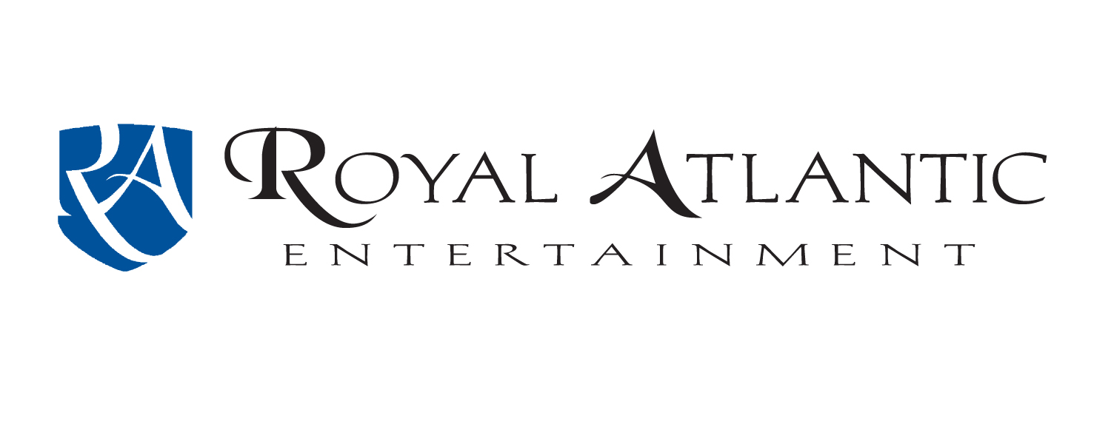
Your One-Stop Entertainment Source:

Bands, Clowns, Face-Painters, Jugglers, Ponies, Petting Zoo, Inflatables, Strolling Musicians, Karaoke, Dunking Booths, Mimes, Comedians, Magicians, DJs.



Beach Music
Oldies
Country
Southern Rock
Jazz
Big Band
Swing
Bluegrass
Motown
Blues
Top-40
Pop
Steel Drums
Classic Rock
Who calls us?

Stihl
Norfolk Festevents
Tidewater Builders Assn
Operation Smile
Neptune Festival
Colonial Williamsburg
Country Clubs
City Parks & Recs
Westminster Canterbury
Atlantic Shores
And in cooperation with Southern Entertainment:
Norfolk Tides
Norfolk Admirals

Call Dave at (757) 548-1873

Royal Atlantic Entertainment Dave Jacobson - Owner Chesapeake, VA
Office: (757) 548-1873 Cell: (757) 575-4095 E-mail: royalmusic@cox.net

